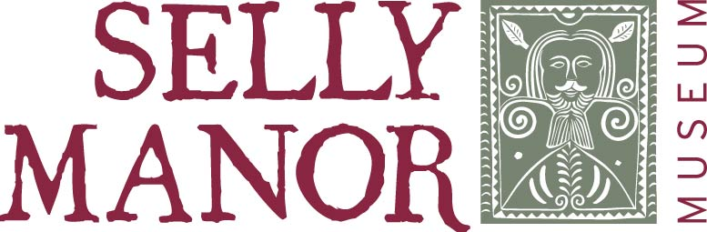

Steps to Volunteering

- Read the Volunteer Role Description and visit the museum to talk to us if you wish. You could also visit our website to get an idea of the work of the museum.

- If you are interested, complete and return the Application Form and the optional Equality Form.

- All volunteers will be invited for an informal interview to discuss the role and what they would like to do and get from volunteering.

- If you are successful, you will be informed and given a copy of the Volunteer Handbook and asked to sign the Volunteer Agreement.

- You can start to volunteer as soon as we are able to allocate you a shift.

Selly Manor will maintain a record of basic information on you, which will include contact information for health and safety and insurance purposes. This information will be subject to the General Data Protection Regulations May 2018 and will be treated in the strictest confidence and not shared with anyone else. You can ask to see the information we hold on you at any time.

Daniel Callicott
Heritage Manager

0121 472 0199
sellymanor@bvt.org.uk
www.sellymanormuseum.org.uk

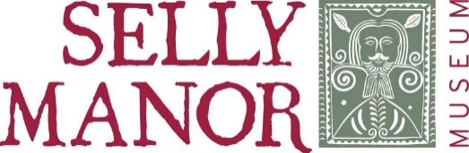
Events & Weekend Volunteer Role
Selly Manor Museum is in the centre of Bournville, adjacent to the village green. There are 2 buildings on site, both moved into the village by George Cadbury in the early 1900’s. It has an award winning education service and a popular and very successful events programme.
Role Profile
This role is to assist museum staff to deliver the events programme and weekend opening, to make all our visitors feel welcome and to be the public face of the museum. We are looking to recruit a small team of about 6 volunteers for this role.
Role Title | Events and Weekend Volunteer
Responsible to | Heritage Manager
Works with | Museum Staff  Volunteers
Role Purpose | To welcome visitors and support museum staff in delivering the events programme.
Key Tasks | Providing a warm friendly welcome to all visitors and giving information on the museum and events  - Answering queries, referring on to a member of staff if necessary  - Enhancing the visitor experience  - Providing additional support or help to visitors who may need it  - Selling gifts from shop  - Using a till and card machine  - Serving and selling refreshments  - Ensuring children are supervised at all times and do not enter the museum unsupervised  - Making visitors aware that food and drink should not be brought into the museum  - Being aware of Health and Safety Policies  - Monitoring museum rooms for overcrowding, tidiness, security and damage  - Ensuring fire exits are not blocked  - Option to give guided tours of the museum for groups  - Providing historical information about the building, museum collection and the local area
Supporting museum staff at a range of events throughout the year and at weekends July, August (opening hours 10am-5pm)
- Attending reliably and regularly as agreed in the rota and let museum staff know in good time if they are unable to attend
- Assisting in creating events, setting them up and tidying away
- Working collaboratively as part of team of volunteers and staff
- Encouraging visitors to take part in events, trails and activities
- Helping families to participate in making crafts, keeping craft area tidy and replacing resources
- Serving tea and coffee
- Engaging with visitors of all ages
- Photocopying
- Stewarding the museum
When | - Events run throughout the year, on any day or evening of the week  - Events can be half-days, full-days or week long. Our standard opening hours are 10-5 Tues to Fri, Sept to May and 10-5 everyday July, August.  - Flexible hours to suit, but for events a minimum of 2hrs per day would be required, and for a weekend you could choose either the morning shift 9.45am – 1.30pm, or the afternoon shift 1.30pm – 5.15pm or both shifts. You can commit to as many or as few shifts as you want.
What you will gain | - Experience in customer service  - Chance to develop new skills  - Enhanced CV  - Opportunity to support a range of different events  - Historical knowledge  - Be part of a small and friendly team  - Help the local community
What will we provide | - Reasonable travel expenses will be provided  - Full training will be given for all aspects of the role  - You will always work alongside an experienced member of staff  - A full briefing will be given to all volunteers before any event  - We may carry out a DBS check  - Volunteers will be covered by BVT’s insurance

Person Specification
 | Essential | Desirable
Knowledge and Skills | - Good communication skills and the ability to provide a friendly welcome  - Enthusiasm for the museum and our aims  - Happy to interact with visitors of all ages  - Comfortable talking to a range of people  - Work quickly with minimum supervision once trained  - Enjoy working as part of a team  - Ability to follow basic safety and security procedures  - Able to deal politely with difficult customers  - Friendly, reliable and energetic | Basic IT Skills  Experience of working with the public

Physical access to the buildings is limited, but wherever possible we aim to accommodate any specific needs.
Event and Weekend Volunteer Application Form
Personal Details
Name
Address

Email
Phone
Emergency Contact Details
Name
Phone
Which role are you interested in? You can tick both
Events |  |  | Weekend
Please tell us a little bit about why you are interested in volunteering, and what personal qualities, experience or skills you have which would help you in the role. This does not have to be formal qualifications, we appreciate skills you will have developed in any situation. We will assess your skills and suitability in relation to the role.
What do you hope to get from volunteering with us? Do you have any specific goals? Are there any skills you would like to gain?
Please tell us about any support needs you have that would help you to volunteer with us.

We are legally obliged to ask if you have any unspent criminal convictions or if there any actions pending against you.
This will not necessarily prevent you from volunteering as it depends on the offence and relevance to the role. Each case is dealt with on its own merits. It will be a requirement to undergo a DBS check for certain roles.
Yes |  | No

Please supply the names and addresses of 2 people who we can contact to provide a character reference. This could be a previous employer, teacher, neighbour. Referees cannot be relatives.
Name |  | Name
How do you know them? |  | How do you know them?
Address |  | Address
Email |  | Email
Phone |  | Phone

Please confirm that you have the right to volunteer within the UK (please tick)
I confirm that I am a UK resident and therefore have the right to volunteer within the UK.
I confirm that I am a citizen of the European Union or European Economic Area and therefore have the right to volunteer.
I have refugee status or exceptional leave to remain and therefore have the right to volunteer.
I am an asylum seeker and therefore have the right to volunteer.

Data Protection:
The information detailed in this application form will be used in the recruitment process and to assess your suitability to volunteer with us. The Equality Monitoring Form is anonymous and used solely to check if we are attracting volunteers from diverse backgrounds and to try to make changes if necessary.
Declaration:
I consent to Selly Manor Museum (Bournville Village Trust) recording and processing the information in this application form. I understand that this information may be used by BVT in pursuance of its business purposes and that BVT comply with their obligations under the Data Protection Act 1998 and from May 2018, the General Data Protection Regulations.

I confirm that to the best of my knowledge, the information provided on this form is correct.
Signature: | Date:

Please return this form by post to:
Selly Manor Museum, BVT, 350 Bournville Lane, Bournville, Birmingham, B30 1QY
Or by email to:
sellymanor@bvt.org.uk

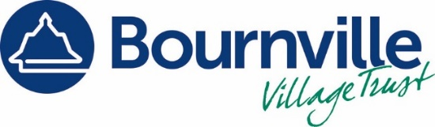

Equality Monitoring Form

Completing this form is voluntary and if you choose not to complete it, this will not affect your application to volunteer.
We are committed to Equality and Diversity and one of the ways we do this is by collecting information. Any information provided will be strictly confidential and you do not need to give your name or address.
Gender
Male / Female / Prefer not to say
Sexual Orientation
Heterosexual / Gay / Lesbian / Prefer not to say
Disability
Do you consider yourself to be disabled? Yes / No
Do you have a long-term illness or chronic condition? Yes / No
Age group
Up to 18 36 - 44
19 – 25 45 - 55
26 – 35 Over 55
Ethnic Origin
A White  English  Welsh  Scottish  Northern Irish  British  Irish  Other white  (please specify) | B Mixed/ multiple ethnic group  White and Asian  White and Black African  White and Black Caribbean  Other Mixed (please specify)
C Asian or Asian British  Bangladeshi  Chinese  Indian  Kashmiri  Pakistani  Other Asian  (please specify) | D Black or Black British  African  Caribbean  Other Black  (please specify)
E Other ethnic groups
Arab
Gypsy or Traveller
Other (please specify)

